SIMATS ENGINEERING
ASSESSMENT TOOL 3

COURSE NAME: Artificial Intelligence COURSE CODE: CSA1709
Register Number | Ganji Madhan Kumar
Name | 192472328

COURSE OUTCOME COVERED

CO1: Apply AI basics such as intelligent agents and uninformed search methods to solve problems effectively.(BL3)

Assessment Tool Weightage: 10%

QUESTIONS:2 Total Marks:20

Descriptive Test

- A smart home automation system is being designed to manage lighting, temperature, and security based on user behaviour and environmental conditions. The system must respond to real-time inputs such as motion detection, temperature changes, and time of day while also learning user preferences over time. In this context, explain the different types of intelligent agents (simple reflex, model-based, goal-based, and utility-based agents) and analyze how each type would function within this system. Justify which type of agent or hybrid approach would be most effective for ensuring comfort, energy efficiency, and security.
- A robot is placed in an unknown maze and must find a path to the exit without prior knowledge of the layout. Explain how uninformed search strategies like Uniform Cost Search (UCS) and Iterative Deepening Search (IDS) can help solve this problem.
Discuss the advantages and disadvantages of these algorithms in terms of time and space complexity. Relate the problem to different types of intelligent agents and explain how agent design affects decision-making. Suggest which combination of agent type and search strategy would be most effective and justify your choice.

Code of Conduct:

I Ganji Madhan Kumar(192472328)certify that this submission is my original work and that I have adhered to the guidelines specified for this assessment.
I understand that any violation of academic integrity rules will result in disciplinary action.

Signature of the student:
G.Madhan Kumar

RUBRICS FOR CALCULATION:

Criterion | Level 4 (Exemplary) | Level 3 (Proficient) | Level 2 (Developing) | Level 1 (Beginning) | Max Marks
Criteria | Level 4 (Exemplary) | Level 3 (Proficient) | Level 2 (Developing) | Level 1 (Beginning) | Max Marks
Understanding of Concepts | Demonstrates thorough, accurate understanding of concepts | Good understanding with minor gaps | Basic understanding with some misconceptions | Poor understanding; major misconceptions | 5
Explanation | Detailed, well-explained answers with relevant examples | Clear explanation with adequate details | Limited explanation; lacks depth | Poor or unclear explanation | 5
Application | Effectively applies concepts with strong analytical ability | Applies concepts with minor errors | Limited application with weak analysis | No application or incorrect analysis | 4
Organization | Well-structured answers with logical flow and coherence | Organized with minor issues in flow | Basic structure, lacks clarity | Poor organization, incoherent answers | 3
Accuracy | Completely accurate and covers all required points | Mostly accurate with minor omissions | Partially correct with missing points | Incorrect answers with major gaps | 2
Clarity | Clear, neat, professional presentation | Understandable with minor issues | Limited clarity, readability issues | Poorly written, difficult to understand | 1

Q1. Smart Home Automation System and Intelligent Agents
A smart home automation system controls lighting, temperature, and security by responding to environmental conditions and learning user preferences. Artificial Intelligence (AI) uses intelligent agents to perceive the environment, make decisions, and perform actions. Different types of intelligent agents are suitable for different tasks within the system.

1. Simple Reflex Agent
A Simple Reflex Agent makes decisions based only on the current percept without considering previous states.
Working in Smart Home:
- Turns on lights when motion is detected.
- Switches off lights when no motion is detected.
- Activates an alarm immediately when a door sensor detects intrusion.
Advantages
- Fast response.
- Easy to design.
- Low computational cost.
Limitations
- Cannot remember previous events.
- Cannot adapt to user habits.
- Performs poorly in complex situations.

2. Model-Based Reflex Agent
A Model-Based Agent maintains an internal model of the environment and remembers previous observations.
Working in Smart Home:
- Knows whether occupants are inside or outside.
- Maintains room temperature history.
- Detects abnormal activities based on previous sensor readings.
- Avoids unnecessary switching of appliances.
Advantages
- Handles partially observable environments.
- Makes better decisions using memory.
- More reliable than simple reflex agents.
Limitations
- Requires additional memory.
- More computationally expensive.

3. Goal-Based Agent
A Goal-Based Agent chooses actions that help achieve predefined goals.
Working in Smart Home:
- Maintain room temperature at 24°C.
- Keep all doors locked when occupants leave.
- Reduce electricity consumption.
- Ensure home security.
The agent evaluates different actions and selects the one that best achieves the desired goal.
Advantages
- Flexible decision-making.
- Can plan future actions.
- Suitable for dynamic environments.
Limitations
- Requires planning algorithms.
- Slower than reflex agents.

4. Utility-Based Agent
A Utility-Based Agent selects actions that maximize overall utility by considering multiple objectives simultaneously.
Working in Smart Home:
- User comfort
- Energy efficiency
- Security
- Electricity cost
Example:
If electricity prices are high, the system slightly increases the AC temperature while maintaining occupant comfort.
The utility function evaluates all available actions and selects the one with the highest overall benefit.
Advantages
- Optimizes multiple objectives.
- Learns user preferences.
- Provides intelligent decision-making.
Limitations
- Utility function design is complex.
- Requires higher computational resources.

Best Agent for Smart Home
A hybrid approach combining Model-Based, Goal-Based, and Utility-Based Agents is the most effective.
Justification
- Model-Based Agent maintains environmental information.
- Goal-Based Agent plans actions to achieve user-defined goals.
- Utility-Based Agent optimizes comfort, security, and energy efficiency simultaneously.
This combination provides:
- Personalized automation
- Reduced energy consumption
- Improved home security
- Better user satisfaction
- Adaptive learning over time
Therefore, a hybrid intelligent agent offers the best overall performance for modern smart home systems.

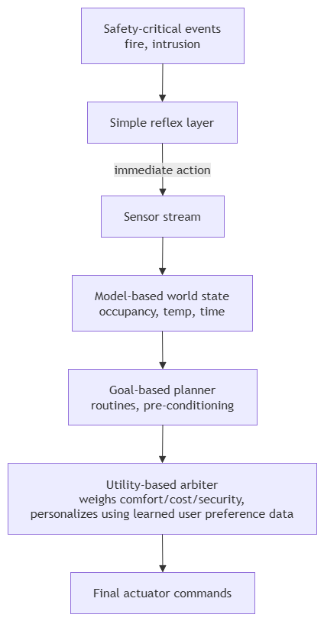

Q2. Robot Navigation Using UCS and IDS
A robot is placed inside an unknown maze and must find the exit without prior knowledge of the environment. The robot explores the maze using uninformed search algorithms.
Uniform Cost Search (UCS)
Uniform Cost Search expands the node with the lowest cumulative path cost.
Working:
- Start from the initial position.
- Store frontier nodes in a priority queue.
- Expand the least-cost node.
- Continue until the exit is found.
Example
If different paths have different travel costs:
- Path A = Cost 12

- Path B = Cost 8
- Path C = Cost 15
UCS selects Path B because it has the lowest total cost.
Advantages
- Finds the optimal path.
- Suitable for varying movement costs.
- Complete if step costs are positive.
Disadvantages
- Requires large memory.
- Time-consuming for large search spaces.
Complexity
- Time: $O\left(b^{1+⌊C^{*}/ε⌋}\right)$
- Space: $O\left(b^{1+⌊C^{*}/ε⌋}\right)$

Iterative Deepening Search (IDS)
IDS combines the advantages of Breadth-First Search and Depth-First Search.
Working
The algorithm repeatedly performs depth-limited searches.
Depth limits:
- Depth = 0
- Depth = 1
- Depth = 2
- Depth = 3
The search continues until the exit is found.

Advantages
- Very low memory usage.
- Complete.
- Finds shallow solutions quickly.
Disadvantages
- Repeats node expansions.
- Less efficient for weighted paths.
Complexity
- Time: $O(b^{d})$
- Space: $O(bd)$
Where:
- $b$= branching factor
- $d$= depth of solution

Relation to Intelligent Agents
Simple Reflex Agent
- Makes decisions only from current observations.
- Ineffective in an unknown maze because it cannot remember explored paths.
Model-Based Agent
- Stores visited locations.
- Builds an internal map of the maze.
- Avoids revisiting the same locations.
Goal-Based Agent
- Plans movements toward the exit.
- Selects actions that move closer to the goal.
Utility-Based Agent
- Evaluates multiple factors:
  - Shortest distance
  - Lowest energy consumption
  - Safety
  - Time required
It chooses the action with the highest overall utility.

